Seasonal Flu Planning Guide 3

INTRODUCTION
This guide has been produced to assist practices when planning the operational aspects of their FLU delivery programme 2020/21 and is a supplementary update to version 1 issued 6th August 2020 and version 2 issued 25th September 2020. We would encourage colleagues to read the three documents in conjunction with each other and note additional references and reading guidance at the end of each document.
In response to feedback, this update has been constructed to relay only information gained and received since the release of version 2, so that colleagues can easily identify what is now available. Information has been sourced from central NHS England directions, the LMC, LPC (Local Pharmaceutical Committee) and commissioners, and has been included based on issues and challenges from Practice Managers and GPs across Surrey and Sussex. Colleagues can read the guidance in its entirety or click on the topic heading in the contents below to be taken directly to that topic within the guide. We hope you find this easy access useful.
Please note that at the time of this release all expected comprehensive central governance has been received, albeit there are several issues of clarity which may emerge over time. It is therefore our intention to make this the last of the comprehensive guides but continue any further release of information through Dr Parker’s regular written correspondence, Practice Managers webinars or local Task and Finish groups.
To date, statistics show that all practices have made a great start and have reported, as expected, a greater demand for vaccinations, even within the eligible cohorts. We would like to say a big thank you for your sterling efforts which indicate early expectations that the targets set for general practice, if the effort and the availability of vaccines are maintained, will be met.
We would continue to encourage everyone to report concerns on any issues related to this year’s flu programme to the CCG, (See Local Practice Support Requirements in the version 1 issued 6th August 2020) so that challenges can be identified, and solutions sought.
Please feel free to raise any of these issues at the LMC/CCG and PMs Webinars.

Contents
Access to additional vaccine supplies 3
Department of Health & Social Care (DHSC) Letter 3
Ordering 3
Claiming & payment processes 4
Auditing 5
Sharing of stocks 5
Damaged or loss of in-practice vaccine 5
Prioritisation of patient cohorts 5
Additional Funding for the expanded flu delivery programme 6
Detailed Flu Coding Guidance 7
Covid-19 Considerations 7
Annex A 8
DHSC Centrally Supplied Flu Stock 8

Access to additional vaccine supplies

Department of Health & Social Care (DHSC) Letter
On 9th October NHS England published a detailed letter describing the arrangements in place for GP Practices to access Department of Health & Social Care (DHSC) reserved stocks of additional flu vaccines.
There are several key points within it that practices should be aware of, including: -

Ordering

- The additional supply of influenza vaccines, which will arrive later in the season is intended to be used to top up local supplies once they run low.
- Practices should only order free DHSC flu vaccines once their own stock orders are depleted. The majority of vaccine stock should be available in November.
- The LMC advises practices to carefully review what stocks they have, including those allocated or committed to known clinics and patients and when that balance has been accounted for and all in-practice stock depleted , then make an order.
- Wherever possible, do not wait until all actual supplies have been used as the order can take up to 7 days to arrive and this time could be invaluable for continuation of immunisations.
- Practices should only use DHSC stock to vaccinate those patients that fall into eligible groups.
- There are limits on order levels which the DHSC will monitor carefully, and depending on demand, further constraints may be imposed.
- DHSC stock is available to order from 4 different suppliers across different products.
- Minimum and maximum quantities have been stipulated by each provider
- Expected first delivery dates to DHSC are indicative as products are currently being manufactured, so amendments to minimum and maximum amounts may change over the season to manage this.
- If, as a singlehanded practice or following accurate in-house calculations, a practice finds that it requires below the minimum order level, we recommend that practices check locally for a partner to share the order by local arrangement. This will require detailed logging of vaccine numbers and careful storage and transfer processes, as detailed in previous versions of these guides.
- Alternatively, Practices can use the generic email address phe.screening-immsssat@nhs.net to request NHSEI intervention for them to access additional stocks, This may be if there has been a cold chain incident for example or if there is a need to place an order which is lower than the minimum order level from vaccine manufacturers. They will then liaise with the national flu single point of contact (SPOC) for their order to be approved.
- Practices are not allowed to return any originally ordered stock to manufacturers, before placing any centrally sourced vaccines.
- Neither will practices be able to return any unused DHSC flu vaccines; practices should aim not to place more than one DHSC order every 2 weeks
- The sum of all the practice’s orders should not exceed 10% of their total registered list.
- A declaration must be signed by the practice before the order can be processed.

Claiming & payment processes

- Payment arrangements under the DES remain unchanged as a £10.06 Item of Service payment. GP practices will be provided with the DHSC vaccines free of charge but will only be able to claim an item of service fee for each DHSC supplied vaccine that is administered.
- Please note, the four flu-related QOF indicator points values are doubled; and the PCN wide >65-year incentive payment under the Investment and Impact Fund (IIF) has been confirmed.
- Practices can claim the DES Item of Service (IOS) fee of £10.06 but not any other reimbursements in relation to the DHSC vaccines, which are provided free. Full details of how to claim fees is here.
Practices will have to sign a declaration to obtain DHSC vaccine supplies which describes the way such vaccines should be ordered and used.

Claiming process from central Flu vaccine supply

Auditing

  - As noted above, there is likely to be an enhanced Post-Payment Verification (PPV) process next year in relation to the flu DES, so it is imperative that practices exercise very tight ordering, administering, and claiming processes. If ever in doubt as to what to record, always make sure you can evidence every step and action, should the need arrive to provide proof of appropriate claiming.
  - Part of the process to access the ordering of centrally held stock is that practices will be required to sign two self-certification declarations:
    - To the manufacturers before accessing stock
    - To NHS Business Services Authority (acting on behalf of NHSEI) at the end of the season as part of the PPV
  - A submission of the PPV form will be required at the end of the season.

Sharing of stocks

- The MHRA (Medicines and Healthcare Products Regulatory Agency) has agreed a dispensation that with appropriate safeguards will allow practices to move vaccine stock between themselves and other NHS providers including Community Pharmacists.
- Practices are advised to check with local practices (and PCNs) for available stock to share before ordering although, because of the high demand, it is unlikely that this will be the case.
- (A proportion of free DHSC stock is being reserved for Acute Trusts and Community Pharmacies)

Damaged or loss of in-practice vaccine

- Systems should be in place to store and administer locally and DHSC supplied stock to support accurate record keeping.
- Practices should check carefully that they have adequate vaccine compliant fridge space, bearing in mind the extra supplies required and the need to keep all stock away from the back and sides of the fridge. If in doubt and to avoid the regrettable risk of damaging stock, please consider the purchase of an additional fridge
- Should stock become damaged for whatever reason , please record the quantity and numbers so that the difference from what the system may expect you to have, and what you now effectively have, can be accounted for.

Prioritisation of patient cohorts

- The eligibility cohorts have been widened. However, the 50-64-year-old age cohort has not yet been included in the NHS DES and will not be until the Government makes an announcement confirming this and the way it will be delivered. GPs should not offer patients in this cohort a flu immunisation unless of course they are eligible for other reasons.
- A ‘Why and I being asked to wait?’ poster has been released by PHE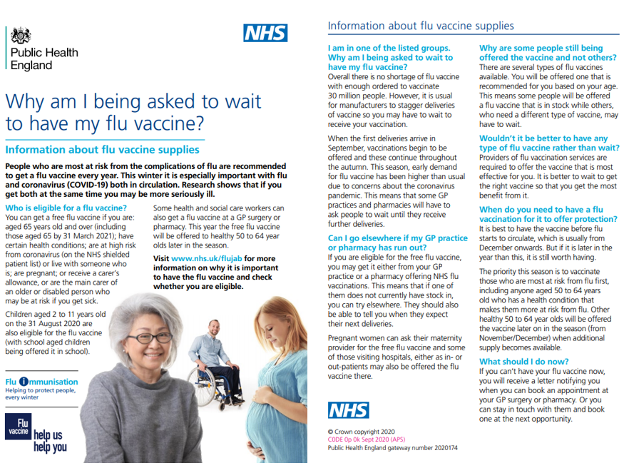
- Practices should prioritise available flu stocks for the currently defined eligible cohorts.
- DHSC vaccines should only be used for patients in line with JCVI (Joint Committee on Vaccination and Immunisation) eligibility recommendations and until the government announces this, the 50 – 64 age cohort are not eligible. DHSC vaccines should therefore not be ordered in anticipation of the likely demand from this cohort

Additional Funding for the expanded flu delivery programme

- Originally information was that there will be no extra funding to support general practice to deliver this enhanced delivery programme, however we have recently been informed that a tranche of funding will come down centrally to be held by CCGs which can be used for this purpose.
- Criteria will be provided which claims from practices will need to meet before the funding can be released.
- At the time of going to print, this has not been formally announced yet, or the details of which practices can claim against, although it is widely acknowledged that this will not include staffing cost claims. We fully understand that staffing costs to practices form the greatest cost for delivering the programme but as a nationally administered scheme, there is no local negotiation. We await fuller details.

Detailed Flu Coding Guidance

NHS Digital has released details regarding Seasonal Flu coding which can be found here.

Covid-19 Considerations

- As we encounter a resurgence of Covid-19 with ever ending new guides as to how to safely live our lives and provide services and as we currently operate under the three tier system, we advise all practices to be cognisant of these directives and make any necessary arrangements when delivering the programme.
- Some practices have expressed views as to the difficulties they are experiencing balancing the normal service requirements as well as meeting the expectations of the Flu programme. To this end we would advise practices to carry out a prioritisation of the work they need to do to meet general demand and to consider which areas could be temporarily paused e.g. minor surgery. A partial re-purposing of extended – hours may allow essential time to assist general practice to deliver prioritised services.

Annex A

DHSC Centrally Supplied Flu Stock

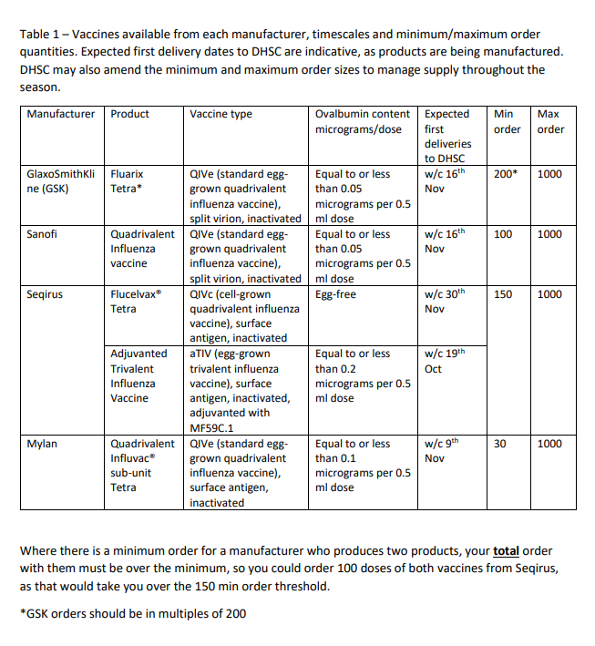

https://digital.nhs.uk/data-and-information/data-collections-and-data-sets/data-collections/quality-and-outcomes-framework-qof/quality-and-outcome-framework-qof-business-rules/enhanced-services-es-vaccination-and-immunisation-vi-and-core-contract-components-2020-2021#seasonal-influenza
https://www.england.nhs.uk/south/wp-content/uploads/sites/6/2020/10/2020.10.09-DHSC-flu-stock-guidance-for-GPs-FINAL.pdf

