Seasonal Flu Planning Guide 2

INTRODUCTION
This guide has been produced to assist practices when planning the operational aspects of their FLU delivery programme 2020/21 and is a supplementary update to version 1 issued 6th August 2020. We would encourage colleagues to read the two documents in conjunction with each other and note additional references and reading guidance at the end of each document.
In response to feedback, this update has been constructed to relay only information gained and received since the release of version 1, so that colleagues can easily identify what is now available. Information has been sourced from central NHS England directions, the LMC, LPC (Local Pharmaceutical Committee) and commissioners and has been included predicated on issues and challenges from Practice Managers and GPs across Surrey and Sussex. Colleagues can read the guidance in its entirety or click on the topic heading in the contents below to be taken directly to that topic within the guide. We hope you find this easy access useful.
Please note that at the time of this release there is an absence of comprehensive central governance on several issues including:
- Access to additional vaccine supplies
- Detailed Patient cohort prioritisation (including in relation to the planned 50 – 64-year-old cohort)
- Funding for the additional costs arising from the expanded delivery programme
- Detailed Flu Coding Guidance

As and when this information becomes available, the guide will be updated.
As before, this guide cannot address everyone’s explicit questions on planning and providing every practice’s Flu Programme. It continues to provide a checklist of considerations with hints and tips on the most salient issues.
Provision has been made for practices to escalate, having compiled their Flu plan, any identified areas, or issues, which require additional CCG support and to report concerns to the CCG, (See Local Practice Support Requirements in the Planning Guide [Release 1]). We would emphatically encourage practices to use this facility so that challenges can be identified, and solutions sought. The LMC/CCG and PMs Webinars also provide fora to raise current issues.
There remains uncertainty in the timescale for the development and delivery of a Covid19 vaccine, and whether this will overlap with the 2020/21 flu season. We will report on this issue when more is known.

Contents
Community Pharmacy and General Practice Flu Guidance 3
Working Together 3
Joint Incentives 3
Notification Arrangements 3
Changes this year – Residential and Care Homes 4
Promotion of Immunisation Services 4
Use of Extended Hours 4
Vaccines 5
Vaccines agreement 5
Flu vaccine storage and stability chart 5
Anaphylaxis 5
Flu Delivery 6
Flu Vaccination of Eligible Patients Previously Diagnosed with Covid-19 6
Flu Delivery via HCAs 6
Occupational Health (Staff Flu) 7
PPE 7
Practice Visual Clinic Planner 8
Flu funding – understanding increased payments in QOF 9
Communications 10
Appendix 11
NHS national flu immunisation programme guidance to manage locally held vaccine stock in primary care providers and NHS Trusts 11
Royal College of Nursing Immunisation Skills and Knowledge Competence Tool 11

Community Pharmacy and General Practice Flu Guidance

Working Together

- Close co-operation between colleagues, meaning pharmacists and general practices in the first instance, at both practice and Primay Care Network (PCN) levels are essential before embarking on any vaccination programme.
- There needs to be a clear understanding as to what vaccination service is being planned and who is to do what, and ideally when and how. This would be diriven by the need to agree on how best to work together locally in the interest of patients.
- Please find below a link to frequently asked questions surrounding funding streams for flu administration. This has been compiled collaboratively between the LMC and the LPC for Surrey and Sussex.
FAQ Flu Funding Streams

Joint Incentives

- NHS England & Improvement has introduced a joint incentive for community pharmacy and general practice at a PCN level, although this represents two separate reimburement arrangements for each contractor group
- The main aim of the joint incentive is to collectively reduce the risk of harm from the influenza virus for all patients aged 65 and over and to reduce pressure on the NHS during winter.
- This will be funded through for GPs, the PCN Impact and Investment Fund (IIF) – PR01, and for pharmacists, the Pharmacy Quality Scheme (PQS) domain 4 PCN prevention respectively.
- Participating pharmacies and GP practices will be rewarded for achieving at or above a specified percentage point (70.1%-77%) for flu vaccination patients aged 65 and over.

Notification Arrangements

- In line with the resepctive service specifications, we encourage information about patient vaccination is passed promptly and accurately to the patient’s NHS practice, using electronic means. Community Pharmacies across Surey & Sussex will be using the PharmOuctomes system to record and transmit vaccine notifications.

- GP practices will receive the full details of the vaccination including read codes, in a PDF document via NHSmail and can add any additional information to the patient record manually as appropriate. Some GP systems can receive structured information, which means details can be added directly to a patient's GP record, without having to transcribe the information manually.

- GP practices should ensure they monitor these communications. As a matter of urgency, practices that haven’t already nominated and activated a secure email for notification purposes, they can email helpdesk@phpartnership.com visit https://pharmoutcomes.org and message the help desk team.

Changes this year – Residential and Care Homes

- GP practices can vaccinate in the residential/care home, residents and staff who are a registered patient with the practice. New this year, will be provisions for community pharmacies to provide the same.

- Local discussion of vaccinations to residential care / nursing home residents and staff is a priority. We would recommend local dialogue should also consider historical plans, especially where vaccine stock has already been already allocated to residential/care home provision by a provider.

- Both the LMCs and LPCs are committed to helping resolve any difficulties that may arise throughout the season. Colleagues are asked to contact their own representative committees in the event of any concerns

Promotion of Immunisation Services

- GP Practices and Community Pharmacy colleagues are equally at liberty to advertise and promote their immunisation services and we would encourage you to pro-actively do so, but both the LMCs and LPCs would urge colleagues not to express this in ways that undermine the other's professionalism in the eyes of each other and our patients

Use of Extended Hours
Considerations:

There is no restriction in the Extended Hours specification about the type of appointment that can be offered, it is permissive in terms of the nature of the healthcare professional whom the patient sees and the reason for the consultation. However, the appointments do have to be recurrent and consistent; that is, at the same time each week.

The LMC do not believe that this means that the appointment type has to be recurrent, as the idea was to tailor Extended Hours to the specific needs of the patient and during flu season obviously there is a need for such appointments. In many cases it would be considered as custom for GP practices to offer ‘flu-clinics’ at times outside core hours, for example, at weekends, to maximise uptake and patient convenience and also avoid some of the disruption that flu clinics could cause during normal hours. It may well be a reasonable to offer a proportion of Extended Hours to be devoted to flu immunisations for a short timescale, perhaps a few months during the flu season, as long as those appointments remain within the recurrent, consistent appointment times that are offered overall

Vaccines

Vaccines agreement
This is an agreement that can be used to enable e.g. community nurses to vaccinate on behalf of a GP practice under their PGD and using their stock. It can be amended for other organisations as well.

Flu vaccine storage and stability chart
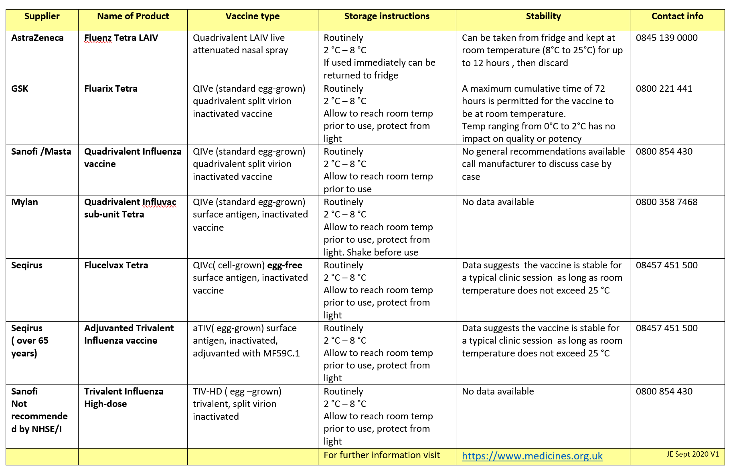

Anaphylaxis

Please see below for details of use and preparation for anaphylaxis when delivering flu vaccines.
- The PSCN guidance states that Pharmacists are required to include anaphylaxis pack as part of their preparation to provide the flu service in the pharmacy or offsite that is inclusive of care homes. Pease see link to the PSNC guidance on page 17, item 15 states: an anaphylaxis pack (check the expiry of the adrenaline ampules, syringes, and needles)
  - https://psnc.org.uk/wp-content/uploads/2020/09/PSNC-Briefing-26-20-Guidance-on-the-Seasonal-Influenza-Vaccination-Advanced-Service-2020-21.pdf. The guidance also includes information on training requirements for anaphylaxis.

- The RCGP has produced Delivering Mass Vaccinations During COVID-19 – logistical guide, please see page 10 for anaphylaxis guidance: https://elearning.rcgp.org.uk/pluginfile.php/149506/mod_page/content/75/Mass%20Vaccination%20at%20a%20time%20of%20COVID%20V2.0.pdf

- The RCN has developed top tips for large scale vaccine delivery, please see link with guidance on anaphylaxis: https://www.rcn.org.uk/clinical-topics/public-health/immunisation/immunisation-services-and-large-scale-vaccination-delivery-during-covid-19#toptips

Flu Delivery

Flu Vaccination of Eligible Patients Previously Diagnosed with Covid-19

- The current guidance as of 25th September 2020 is that a patient can have the flu vaccine 10 days after the start of symptoms, providing the patient no longer has a high temperature. Patients eligible to receive NHS-funded flu vaccine but recently in contact with, or diagnosed with, the COVID-19 infection can be vaccinated when recovered and self-isolation requirements have been fulfilled. Immunisers should refer to the Gov.UK Coronavirus pages to ensure recommendations that are current at the time of vaccination are followed.

Flu Delivery via HCAs

- Check these have been received and signed by your nurse team; this should be kept as evidence as part of the HR file.
- HCAs can be involved in the delivery of flu vaccines to adults (IM injection) and children (only the nasal flu vaccine). As this is a delegated role, all practices should have a robust process in place to ensure that both the HCA and the supervisor need to be clear about accountability regarding the delegation and performance of this procedure. All HCAs should be practicing under a PSD written by the delegating professional which could be the patient’s GP or a Nurse Prescriber.

Please see below the links to the PHE HCA Training standards:
https://assets.publishing.service.gov.uk/government/uploads/system/uploads/attachment_data/file/464033/HCSW_Training_Standards_September_2015.pdf

Information on HCAs to administer vaccines – see this link
https://www.themdu.com/guidance-and-advice/guides/flu-and-flu-vaccinations

The national team has published a guidance document on flu immunisation training to support healthcare professionals during the COVID-19 pandemic.
https://www.gov.uk/government/publications/flu-immunisation-training-recommendations

Occupational Health (Staff Flu)

- Staff vaccinations against flu is not covered within the state indemnity scheme, the Clinical Negligence Scheme for General Practice (CNSGP). The three main indemnity organisations have suggested practices contact their practice indemnity insurer as the administration of flu vaccine in these circumstances may be covered by arrangements already in place; the LMC suggests this should be confirmed by all practices who may wish to immunise staff directly.

- The following options are available to practices:
  - All staff with a clinical condition which makes them eligible for the NHS national seasonal influenza vaccination programme should be encouraged to attend their registered GP practice (or a community pharmacist) to obtain this immunisation. As of course you may not be aware whether staff are eligible, this should be given as generic advice.
  - Some GP practices may have commissioned an Occupational Health Service for staff; if this offers seasonal flu immunisation, this service can be used.
  - Practices can adapt the national PHE PGD and named nurse/s within the practice can then vaccinate practice staff; a GP within the practice needs to sign the PGD and thereby assume responsibility for this administration. The PGD is available below: https://www.sps.nhs.uk/articles/writteninstruction-for-the-administration-ofseasonal-flu-vaccination/
  - Practices would need to ensure:
    - A record of the immunisation is kept
    - Encourage the staff member involved to share this information with their registered GP and obtain consent to do so.
    - Ensure confidentiality of the staff members’ clinical information, enquired about during the immunisation process
  - In terms of the above option the LMC advises indemnity is confirmed beforehand.
  - Practices could offer to pay for privately obtained flu immunisation from another provider.
  - A GP in the practice could generate a Patient-Specific Direction (PSD) for each staff member to be immunised; again, indemnity arrangements should be confirmed beforehand.

Locum GPs are eligible for influenza immunisation via their registered GP under the 2020/21 DES

PPE
On the 21st August 2020 further information from the Head of Infection Prevention & Control South East Region, NHSE was released, which relates to the PPE requirements for Flu clinics. The requirements are now confirmed in writing in the updated IPC Guidance (excerpt and link below).

Vaccine and injection clinics: as stated page 14
In some clinical outpatient settings, such as vaccination/injection clinics, where contact with individuals is minimal, the need for single use PPE items for each encounter, for example, gloves and aprons is not necessary. Gloves and aprons are recommended when there is (anticipated) exposure to blood/body fluids or non-intact skin. Staff administering vaccinations/injections must apply hand hygiene between patients and wear a sessional facemask. Link to the new IPC guidance for remobilisation of services is now published

Practice Visual Clinic Planner

Overleaf is a visual planner which may be very useful in the practice for everyone to refer to; you can also download a word version of this Clinic Planner by clicking the embedded document.
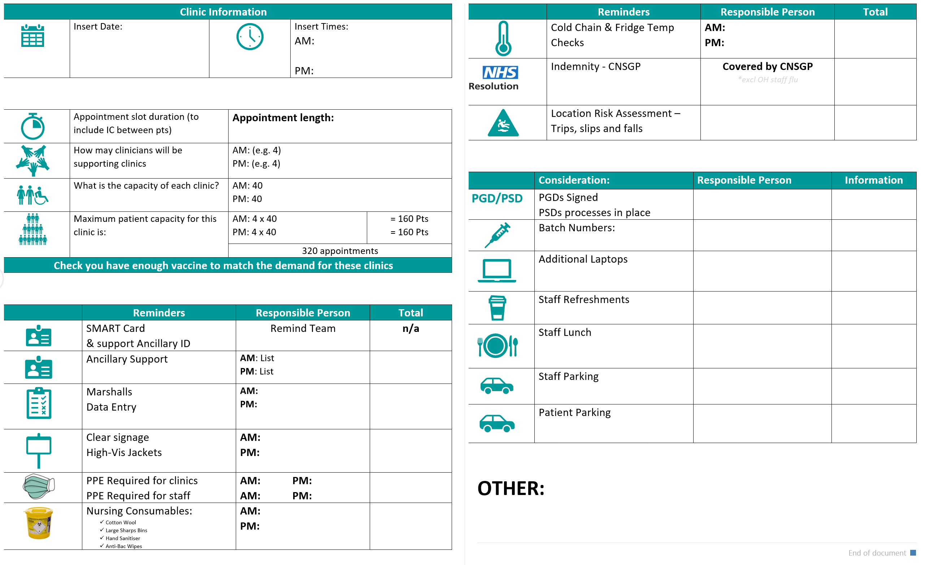
If you do not wish to use a visual planner, or, need assistance compiling your own, then here are a few considerations you might want to make:

- Preparation and Planning
- It is important to be aware of when your deliveries are due to arrive, it might be useful to check your delivery dates and confirm all is in order with your supplier. Always have a plan B.
- Social distancing: consider markings on the ground; inside and out. Clear signage will support your clinic delivery.
- Staff could be sent an admin instruction on what to do before arrival on the day.
- Vaccinators could potentially work in both areas; inside and out.

- Clinical Processes
- Patients could be given specific times so that numbers of patients waiting at any one time can be more easily managed.
- Consider what works well for your practice in terms of minute intervals, and plan accordingly
- Vaccinators could be supported by a dedicated admin person who has access to the GP system. This would minimise problems with infection, protection, and control as there was is no risk of touching a patient, then the computer and then potentially transferring to the next patient.
- Automating data entry using macros. This made it quicker and more accurate.
- dedicate one vaccine only during a session so that there can be no errors.
- Fast track those in wheelchairs and or patients with walking difficulties. This reduces time or blockages of wheelchairs in corridors etc. it also helps with social distancing.

- Support
- Key supporting staff might be Flu ‘Marshalls’ either in car parks or external arrival areas,
- Use of high viz jackets if appropriate for easy recognition.
- reception staff to screen patients for COVID-19 symptoms,
- general guides
- Data entry personnel

- IPC
- Organise, in accordance with PHE guidance, the wearing and changing of masks
- Access to continual hand washing stations as well as including use of sanitiser.

Flu funding – understanding increased payments in QOF

NHSE agreed that the 2020/21 QOF would need to be amended to reflect the impact of Covid 19 on General Practice. Guidance has now been published and can be found here.

The LMC wrote to practices to highlight key themes within the QOF arrangements, it is planned that ‘normal’ QOF arrangements will apply for the 2021/22 financial year: the changes during 2020/21 will be reflected in an amended Statement of Financial Entitlements (SFE) for the financial year which will be published shortly. This year QOF will be divided into three elements.

- Indicators that will be reimbursed based on practice performance; these will represent 183 points in total and the QOF point value of some indicators (being the four flu indicators and two cervical screening indicators) is doubled.
- The Quality Improvement (QI) domain is being amended to focus on restoration of services and care delivery in relation to the previously agreed topics of Learning Disability and Early Care Diagnosis. The QOF value of 74 points is unchanged.
- The remaining 310 points will be subject to income protection based on historic performance and practices agreeing to population stratification approach to QOF and their CCG.

The total Value of QOF remains unchanged at 567 points.

The payment formula has been amended so it no longer runs on a linear scale from 0 points to a maximum points between a lower and upper payments thresholds; instead practices will accrue a greater number of points immediately they achieve the lower threshold scale and the remaining points are then available on a linear basis relating to the lower and upper thresholds.

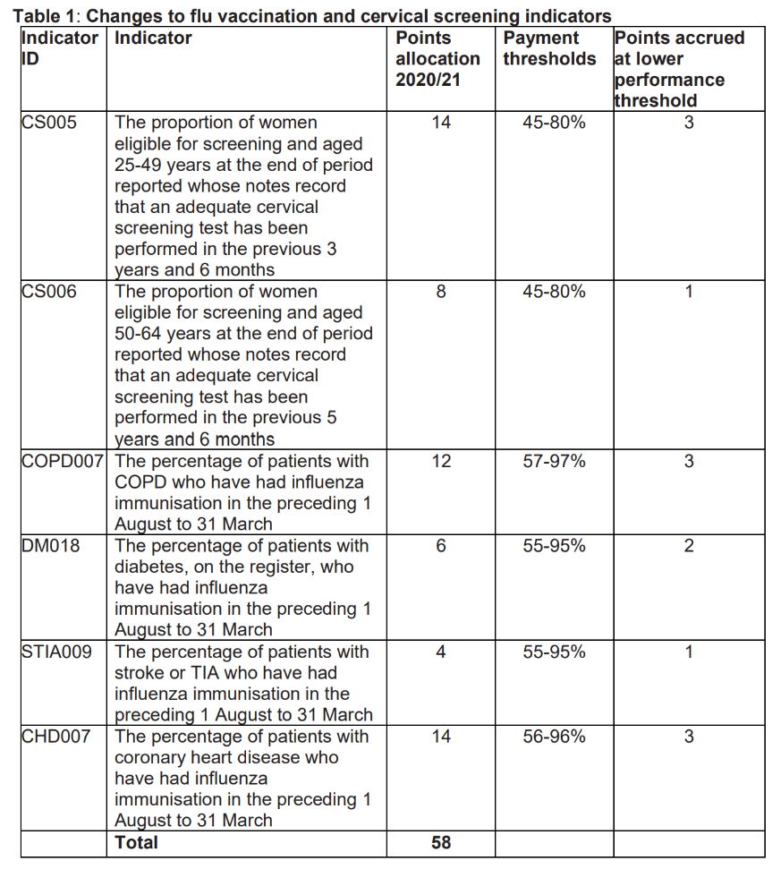

Communications

NHSE GP Statement on 50-64-year olds
For patients
Please note that, if you are aged between 50 and 64 and not in a clinical at-risk group, the earliest you will be offered a flu vaccination is November, providing there is sufficient vaccine. No appointments will be offered for people in this age group until then. This is to ensure that those who are most at risk are vaccinated first. If you are aged 50 to 64 and are in a clinical ‘at risk’ group which is eligible for the flu vaccination, for example you have a health condition which puts you at risk from the flu, you will be invited earlier.
For providers
Please note that flu vaccination for people who are aged 50 to 64 who are not in an at-risk group will not available until November at the earliest, and then only if there is sufficient vaccine. This is to ensure that those who are most at risk are vaccinated first. You should neither invite nor vaccinate to anyone in this age group until advised to do so by the NHS. Please continue to invite and vaccinate those in at risk groups aged 50 to 64 as normal.

Appendix

NHS national flu immunisation programme guidance to manage locally held vaccine stock in primary care providers and NHS Trusts

Royal College of Nursing Immunisation Skills and Knowledge Competence Tool

